**THOMSON IMPLEMENTATION**

**Step1:Installing the backend software in the system**

1. Install nodejs in the system.(<https://nodejs.org/en/>)
2. Install npm in the backend folder of project

**npm install**

After downloading check the version in cmd prompt

**node -v**

**npm -v**

**Backend Folder -->in Folder C-->ThomsonDistApp-->backend**

**Frontend Build file -->in folder C-->C:\nginx-1.18.0\html**

**Step2:Install Visual Studio Code**

[**https://code.visualstudio.com/download**](https://code.visualstudio.com/download)

**Step3: Install MongoDb**

[**https://www.mongodb.com/try/download/community**](https://www.mongodb.com/try/download/community)

Cfolder-->C:\Program Files\MongoDB\Server

**Install Mongodb tools**

<https://www.mongodb.com/try/download/database-tools>

<https://fastdl.mongodb.org/tools/db/mongodb-database-tools-windows-x86_64-100.5.1.msi>

C:\Program Files\MongoDB\Tools\100\bin

**Set both files in environment variables ,search edit the system environment variables in windows--->Environment variables -->select system variables path-->Double click the path--->New and copy the path of Mongodb and Tool.**

**Step4:Download Nginx** **in system**(version 1.18.0)

Save the nginx file in c drive

After downloading nginx copy the above build files in the html folder .(replace Copy the Conf file in nginx)

**Step5:Install build files in system and copy the build files in html folder of nginx**

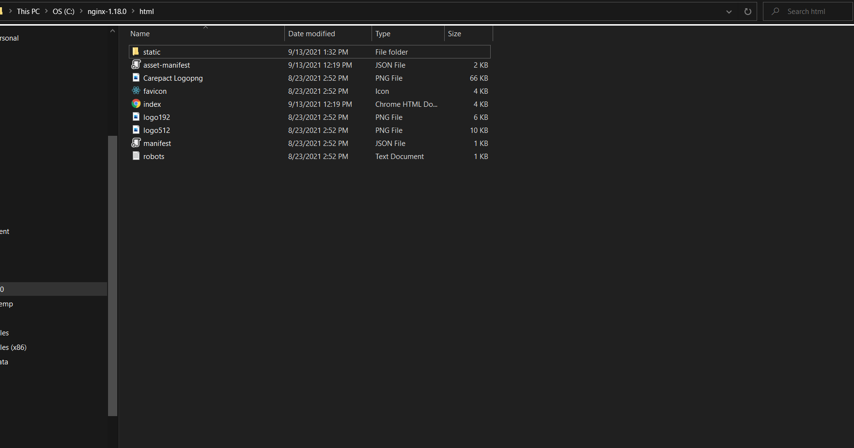

**Step6:Host file Setup**

Here we have to set up the domain name in the host file.First we have to copy the host file to desktop.After that, open the file and edit the domain name.

Path C:\Windows\System32\drivers\etc\host

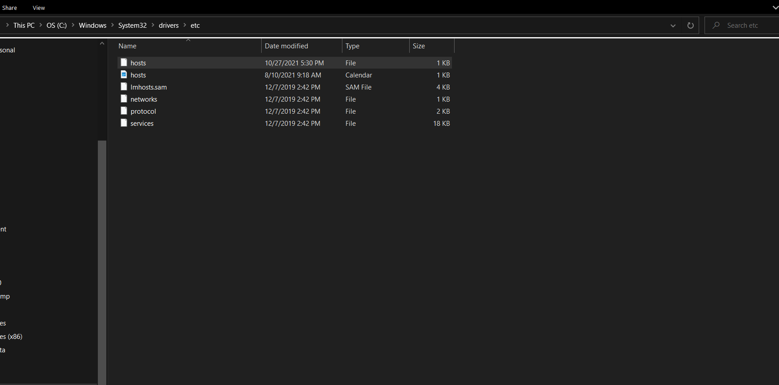

**Edit the domain name of host file**

127.0.0.1 carepactretailapplication.com

127.0.0.1 www.carepactretailapplication.com

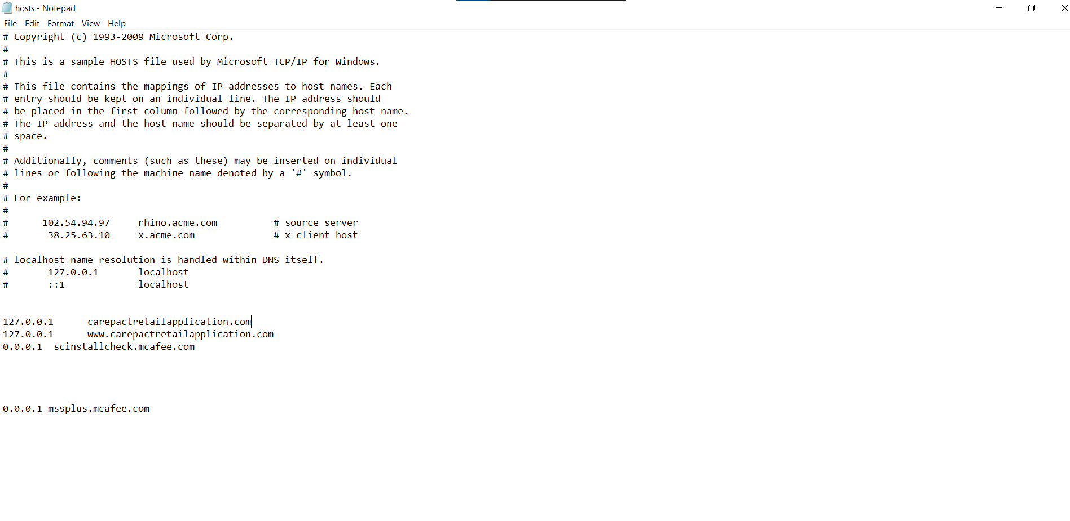

**Step7:Install python (**Latest Version3.9 or latest)

<https://www.python.org/downloads/>

**Python commands to install**

C:\Users\user\AppData\Local\Programs\Python\Python39\Scripts\

pip install pipenv

pip install pymongo

pip install numpy

pip install pandas

pip install xlrd

pip install openpyxl

pip list

Search command prompt python or python3

**python -v**

To find python path in cmd use **where python**

To UPgrade pip

python -m pip install --upgrade pip

**Set both files in environment variables ,search edit the system environment variables in windows--->Environment variables -->select system variables path-->Double click the path--->New and copy the path of python and save.**

C:\Users\user\AppData\Local\Programs\Python\Python39\Scripts\

**PM2 Install**

install the command in cmd prompt **npm install pm2@latest -g**

**pm2 log** to find the logs

**pm2 kill** to stop pm2

D:\newimp\distributor_app-Thomson_Distributor\backend

**Step8: Copy Batch file in system to Run the project**

Copy the batch file in system save it in D folder

In batch file copy the correct nginx path(Eg “C:\nginx-1.18.0”)

Save the file in D folder and change the path in batch file (Eg “D:\project\backend”)

@echo off

start net start mongodb

c:

cd "C:\nginx-1.18.0"

start nginx

set url=http://carepactretailapplication.com:8081/

start chrome %url%

D:

cd "D:\newimp\distributor_app-Thomson_Distributor"

pm2 start server.js

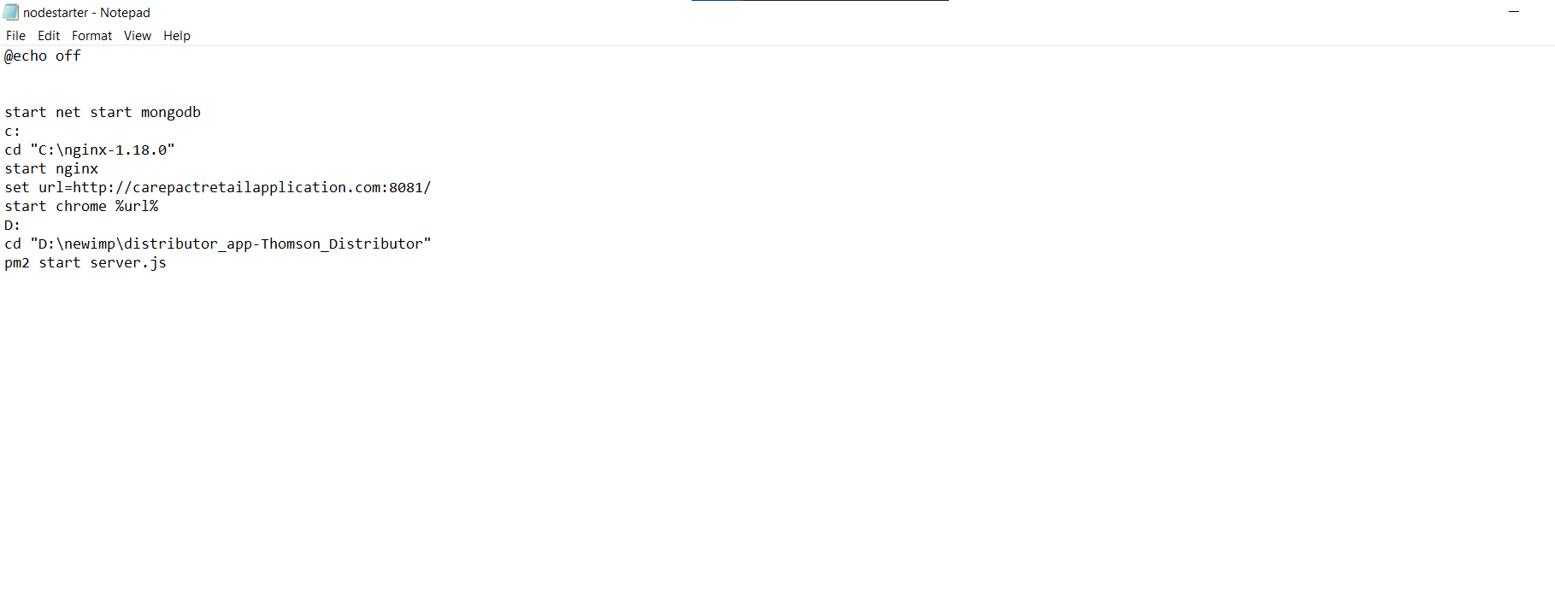

**Step 9:To share folder in computer**

Right click the folder computer → then click properties and share → click the sharing→ give all users permission→ after that it shows the link and copies the link.

After copying the link to which computer we need that folder → click the map network drive and paste the copy link.

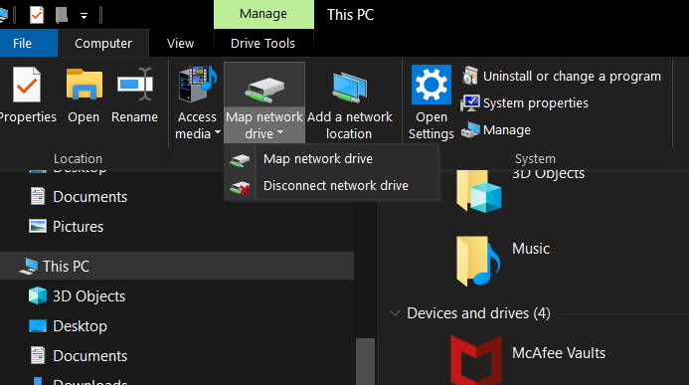

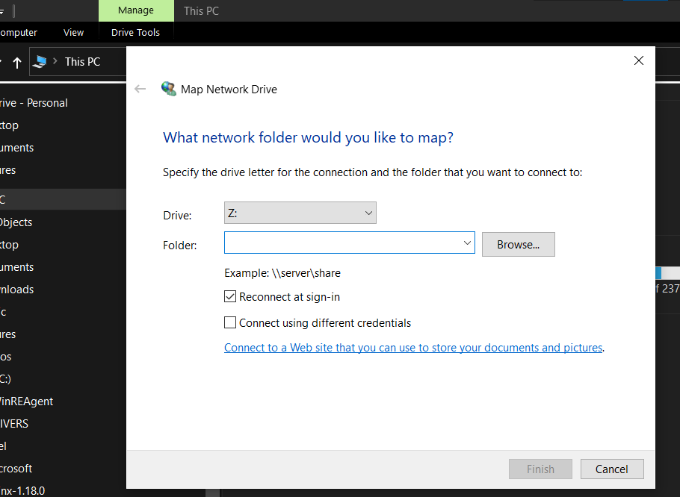

**Reducing the space in Db and delete in Thomson**

db.carepactlogs.update({'products': {'$exists': true}},{ $unset: {'products.$[].image': 1}},{multi: true})

db.carepactlogs.update({},{$unset:{ocrInput:1}},false,true)